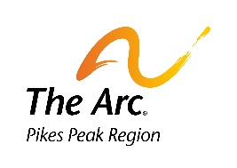
The Arc Pikes Peak Region
AWARD NOMINATION FORM
Annual Awards Celebration
September 27, 2024

Thank you for your interest in nominating our community members for an award at The Arc’s annual dinner and awards celebration. We take great pride in our ability to recognize the outstanding people and work done in our community. We ask that only thoroughly completed forms be submitted, as the review committee may not be familiar with the nominee. We will only review original nomination forms, so please do not submit multiple copies of the same nomination form. Please use a separate form for each person/program being nominated. Copy this form for additional nominations. Nomination forms are due to The Arc PPR by 5:00 p.m., Thursday June 27th, 2024. Please submit forms early so we can get any questions answered prior to the review meeting.

Category (Please check one)
Please note, The Arc PPR and the review committee reserve the right to re-categorize nominations.

□ Public School Personnel  (An employee or volunteer in a Pre-K through transition school. EX: teachers, paraprofessionals, nurses, etc) | □ Professional of the Year  (Person providing professional supports or services in the community. EX: nurse, attorney, therapist, etc.)
□ Support Services  (A person who provides administrative or indirect support. EX: administrative, benefits, bus driver, etc) | □ Outstanding Program  (A program that supports people with IDD in the community. EX: agencies, programs within agencies, etc.)
□ Parent/Family Advocate  (A family member or friend that advocated for the rights & welfare of a person with IDD) | □ Host Home Provider  (A person who lives with & provides direct support to a person with IDD)
□ Residential Service Provider  (DSP & Managers who provide residential services. EX: direct care staff, managers, etc) | □ CES/CHRP Service Provider  (Person or Agency who provides supports to a person receiving services from the CES/CHRP waiver)
□ SLS/EBD Service Provider  (Person or Agency who provides supports to a person receiving services from the SLS/EBD waiver) | □ Vocational/Day Service Provider  (An individual or agency that provides supported employment, day programs, specialized habilitation. EX: job coach, direct care staff, managers, etc)
□ Resource Coordination  (A person who provides case management or helps coordinate services EX: case management) | □ Special Recognition  (Someone who supports an individual with IDD and doesn’t fall into another category. EX. community members, first responders etc.)
□ Achiever of the Year (Individual with intellectual or developmental disabilities who has shown determination to succeed)  *Continued on next page. | □ Employer of The Year  (business employing people with IDD)  □ Other
Who are you nominating for the selected category? (Person, business, program, etc.)

How can we contact this nominee?
Phone #: __________________________ Email:

Address:

Agency & Phone #:

Tell us why we should select this nominee: (Please be detailed and give specific information about what was accomplished by the person or program this past year, how does the program benefit people with I/DD, what makes the nomination unique, how has the person gone above and beyond, etc.; attach additional pages if needed):
Nomination completed by:
How can we contact you?
Phone #: __________________________ Email: _______________________
Address:
Agency & Phone #:
Can we tell the nominee you made the nomination?

Please return nomination forms by Thursday, June 27th at 5:00 p.m. to:

The Arc Pikes Peak Region
10 North Meade Avenue
Colorado Springs, CO 80909
Or fax to: 719-471-4828
Or email: frontdesk@thearcppr.org
Or online: www.thearcppr.org
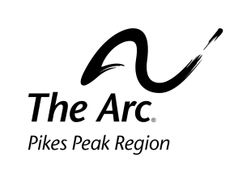
Nomination forms will not be accepted after Thursday, June 27 2024 after 5 p.m.

